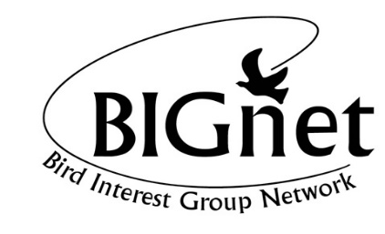 NSW & ACT 2021 Twitchathon – Sponsor Record Sheet

Team Name _______________________________________________________________________________________

Total Species Recorded __________ Club/Society/group to which you belong ______________________

Your Name and Address _____________________________________________________________________________________________

Unfortunately we are not able to provide a tax deductible receipt for these donations.

Name of Sponsor  Please print | Address  Please print | $ amount  per bird  sponsorship | Total $ Donations Collected

Total enclosed $ _____________
Please finalise collection of sponsorship monies by 18th December 2021. Once you have collected all sponsorship monies please
- Pay the total funds by EFT into the BIGnet account. The details are as follows: BSB 182 222, account number 121211833. There is also an option using BPay (Biller code 20206, Ref: 121 211 833). The account name is: Thomas E Karplus & Janet E Galloway & Paul D Vale on behalf of Bird Interest Group Network. The account is a Macquarie Cash Management Account.
- Please also forward this form through to Elisabeth and Tom Karplus, the Twitchathon Coordinators at emhodson@exemail.com.au

